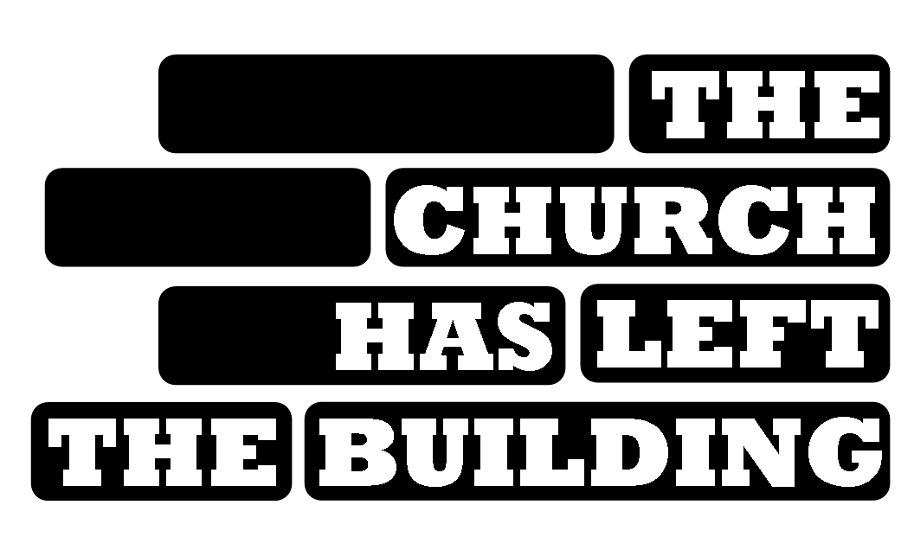

## Sunday, September 25, 2016

# Chambers Hill United Methodist Church 717.561.0388 www.chambershillumc.org

VOLUNTEER REGISTRATION FORM

Name: _____________________ __________________________ (PLEASE PRINT)

(LAST) (FIRST)

Address: ________________________________________ email: _______________

________________________________________

Phone: ________________ _______________

HOME CELL

**UNDER AGE 18?**  
You must have your parent/guardian fill out the consent form on the back of this application.

**CHILD CARE** : Child care will be available for children at our church from 9:00AM to 11:00AM for parents who are serving at other sites.

### Name ______________ Age ____ Name ______________ Age ____

#### PROJECT SELECTION

*Please check a first, second, and third choice project.*

|  |  |  |  |  |  |  |  |
| --- | --- | --- | --- | --- | --- | --- | --- |
| **1st choice** | **2nd choice** | **3rd choice** |  | **1st choice** | **2nd choice** | **3rd choice** |  |
|  |  |  | **#1 Breakfast for Homeless** |  |  |  | **#9A School Playground AM** |
|  |  |  | **#2 Adopt a Highway** |  |  |  | **#9B School Playground PM** |
|  |  |  | **#3 Gleaning for Food Bank** |  |  |  | **#10 Hospice House** |
|  |  |  | **#4 Caitlyn Smiles (KIDS)** |  |  |  | **#11 Fire House Landscaping** |
|  |  |  | **#5 Sewing Project** |  |  |  | **#12 Cookout** |
|  |  |  | **#6 Stop Hunger Now** |  |  |  | **#13 CATRA** |
|  |  |  | **#7 New Life Cleanup** |  |  |  | **#14 Ronald McDonald House** |
|  |  |  | **#8 New Life Playground** |  |  |  | **#15 Nursing Home Hymn Sing** |
|  |  |  |  |  |  |  | **#16 Daystar Painting** |

YES NO 🡨 I wish to work on more than one project (*if time allows*)

If there are specific persons you wish to work with, list the name(s) here:

C:\Documents and Settings\User 1\Local Settings\Temporary Internet Files\Content.IE5\CUPEI56J\MC900064983[1].wmfI will be attending the supper and celebration at 5:00PM YES NO

T-SHIRT SIZE: S M L XL XXL XXXL Children’s: YS YM YL YXL  
 (please circle) OR I already have a t-shirt from last year (design is the same)

Please return this form ASAP to the Church office at 6300 Chambers Hill Road, Harrisburg, PA 17111 by 9/4/16   
  
**Do not write below this line. For Committee Use Only**

**Date Received: _____________ Project Assigned:___________________________________________**



## Sunday, September 25, 2016

# Chambers Hill United

# Methodist Church

PARENT/GUARDIAN PERMISSION FORM

**(*FOR PERSONS UNDER AGE 18*)**

(PLEASE PRINT)

Name of Person under the age of 18: __________________________________

Date of Birth: _____/______/______ Age: ____

Contact Person in case of emergency: _______________________________

Contact Person’s phone number: ________________ ___________________

HOME CELL

Please list any medical conditions and/or allergies that we should be aware of:

Statement of Permission

I, as legal guardian of the above-named volunteer, do hereby give permission for him/her to participate in Chambers Hill UMC’s “The Church Has Left the Building” service project.

This permission also allows the volunteer to be transported to and from a project area if necessary.

Further, I give my permission for my child to receive any medical care deemed necessary.

I also give permission for my child’s picture and video to be taken during the day and used in online, electronic, and print media created for our church.

Physician’s Name and Phone Number: ________________________

Hospital Preference: _______________

Parent/Guardian Name (PLEASE PRINT): _________________________

Parent/Guardian Signature: ______________________________ DATE: _________

(NOTE: This form MUST BE COMPLETED for all persons under the age of 18.)